AI Use Declaration Form
Course: Introduction to Artificial Intelligence
Lab Title: Lab 1 — OOP Search Algorithms
Student Name: __________Oluwademilade Subair_______________________________
Student ID: _____________58742028______________________________________
GitHub Repository Link: __https://github.com/jupiterbouncer/Subair_Oluwademilade_Lab1__
Date Submitted: ___________19th June 2026________________________________

1. AI Use Summary
Question | Student Response
Did you use any AI tool for this lab? | Yes
Estimated percentage of the work influenced by AI | 10 %
Did you attach evidence of AI use where applicable? | Yes

2. Details of AI Use
Complete the table below for each AI tool used. Add more rows where necessary.
Name of AI Tool Used | Purpose for Using the Tool | Prompt or Instruction Given to the Tool | Part(s) of the Work Influenced by the Tool | How I Verified, Edited, or Improved the AI Output
Claude | Generating my own custom maps with specific pathways | “verify I created a map showing the gap in implementation between UCS and A*” | Creating my own custom maps for part B | I ran the command to ensure it was produced the desired grid and weights
Claude | Debugging my code implementation for the A* and IDS* algorithm | “here’s my current code and some of the errors I got after running cells, any red flags or logic I should be worried about” | Bonus IDS* implementation | I already had a working solution but checking for optimal edits or indentation I might not have considered

3. Attachment of AI Output Evidence
Where required, attach evidence of AI use. Tick all that apply. Add more rows where necessary.
Evidence Type | Attached? (Yes, No, N/A) | File Name
AI-generated draft | N/A
Prompt history | N/A
Screenshot of AI interaction | Yes | 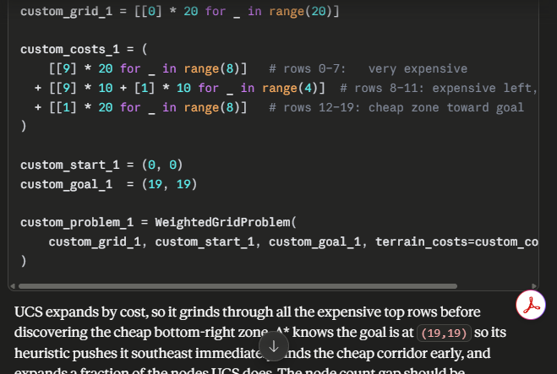
Exported AI conversation | N/A
AI-generated code snippet | Yes | Attached above
Revised version showing student input | N/A

4. Student Declaration
I declare that:
Declaration Statement | Response (Yes/No)
The submitted work is my own work. | Yes
Any use of AI tools has been clearly declared in this form. | Yes
The prompts, instructions, and AI-generated outputs have been disclosed where applicable. | Yes
I reviewed, tested, edited, and improved any AI-generated content before submission. | Yes
My AI usage does not exceed 25% of the entire work. | Yes
I understand that undeclared or excessive AI use may be treated as academic misconduct. | Yes

Student Signature: ___________________________________________
Date: ________________19th June 2026___________________________

